**Experiment 4**

**Aim:**

To prepare Use Case Diagrams for the application software, Object Detection Solution**.**

**Theory:**

**What is a Use Case Diagram?**

In the Unified Modelling Language (UML), a use case diagram can summarize the details of your system's users (also known as actors) and their interactions with the system. To build one, you'll use a set of specialized symbols and connectors. An effective use case diagram can help your team discuss and represent:

* Scenarios in which your system or application interacts with people, organizations, or external systems
* Goals that your system or application helps those entities (known as actors) achieve
* The scope of your system

**When to apply Use Case Diagrams?**

A use case diagram doesn't go into a lot of detail. Instead, a proper use case diagram depicts a high-level overview of the relationship between use cases, actors, and systems. Use cases are represented with a labelled oval shape. Stick figures represent actors in the process, and the actor's participation in the system is modelled with a line between the actor and use case. To depict the system boundary, draw a box around the use case itself. Use case diagrams are ideal for :

* Representing the goals of system-user interactions
* Defining and organizing functional requirements in a system
* Specifying the context and requirements of a system
* Modelling the basic flow of events in a use case

**What are the Components of Use Case Diagram?**

* **Actors:** The users that interact with a system. An actor can be a person, an organization, or an outside system that interacts with your application or system. They must be external objects that produce or consume data.
* **System:** A specific sequence of actions and interactions between actors and the system. A system may also be referred to as a scenario.
* **Goals:** The end result of most use cases. A successful diagram should describe the activities and variants used to reach the goal.

**Use Case Diagram Symbols and Notation:**

* **Use Cases:** Horizontally shaped ovals that represent the different uses that a user might have.
* **Actors:** Stick figures that represent the people actually employing the use cases.
* **Associations :** A line between actors and use cases. In complex diagrams, it is important to know which actors are associated with which use cases.
* **System Boundary Boxes :** A box that sets a system scope to use cases. All use cases outside the box would be considered outside the scope of that system.
* **Packages :** A UML shape that allows you to put different elements into groups. Just as with component diagrams, these groupings are represented as file folders.

**Use Case Diagram for the Application Software – Object Detection Solution:**

Use Case 1:

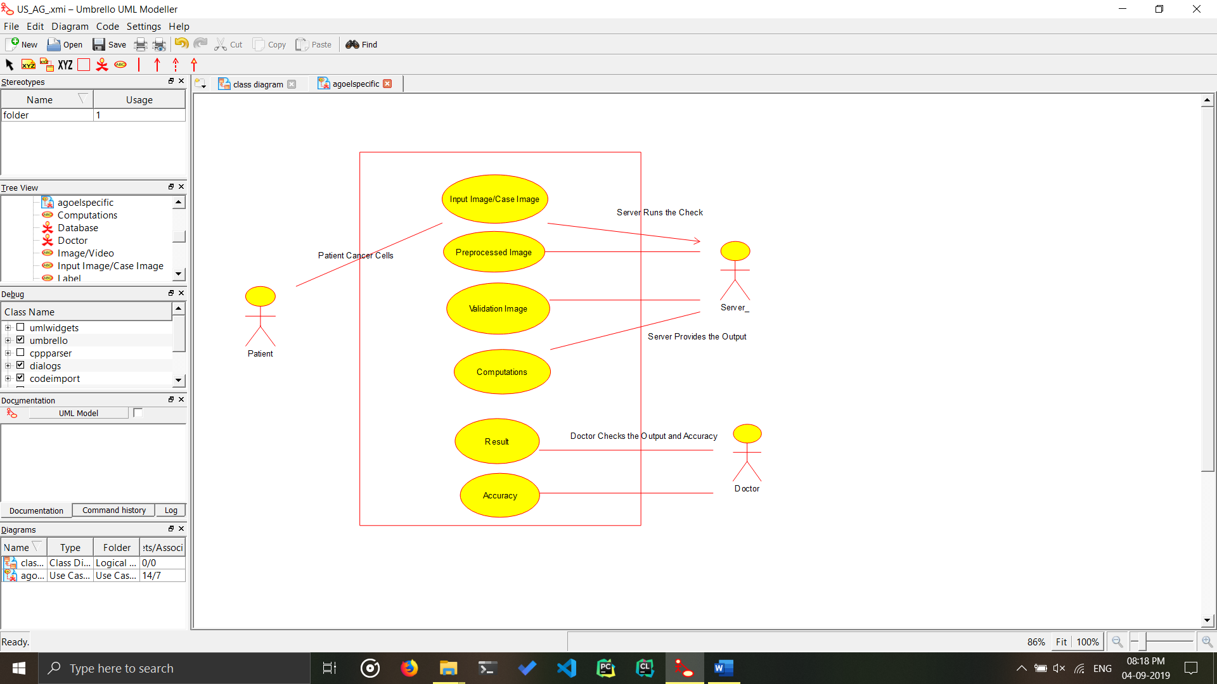

Use Case Diagram for the Cancer Detection in patient, it checks the image of tumour cells of patient and checks and validates it with other data stored in the server, and provides the relevant results. If it is benign or malignant.

Use Case 2:

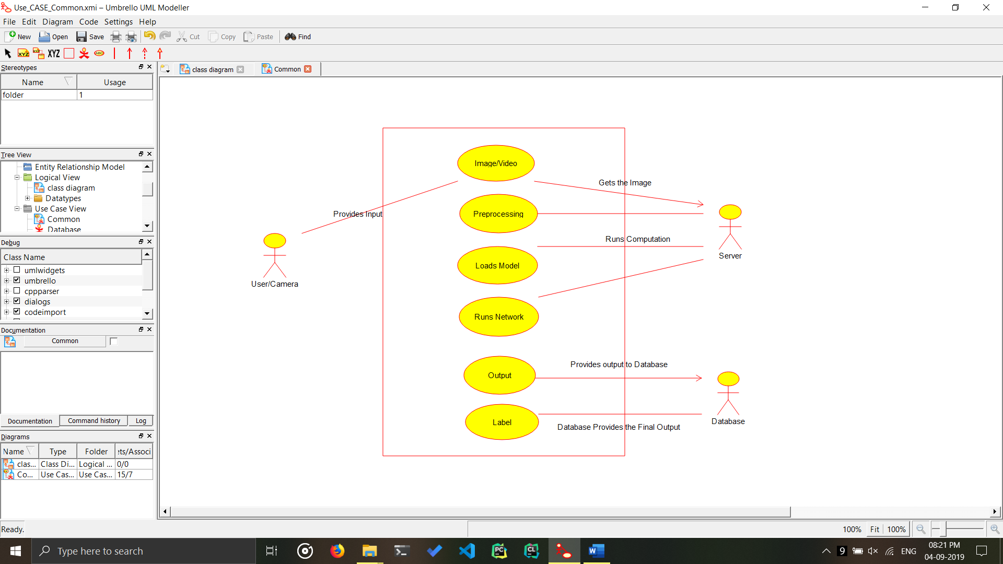

Use Case Diagram for the Object Detection Model, it takes image/video, runs the computation interacts with the server and the database then it provides the relevant results.

**Conclusion:**

The Use Case Diagram has been implemented, and created for the project.